Business Intelligence System Design and Data Warehouse Framework
A Strategic Advancement Report for Retail Store Directors
ICT701 – Assessment Item 2
Based on Retail Store Dataset (January 2022 – March 2022)

Table of Contents
1. Introduction 3
2. Data Description 3
3. Numerical Statistical Summary 3
3.1 Overall Sales Performance 3
4. Visual Analytics and Key Findings 4
4.1 Revenue by Branch 4
4.2 Revenue by Product Line 4
4.3 Monthly Revenue Trend 5
4.4 Payment Method Distribution 6
4.5 Customer Rating Distribution 6
4.6 Revenue Heatmap: Branch by Product Line 7
4.7 Revenue by Gender and Customer Type 8
4.8 Gross Income by Product Line and Branch 8
4.9 Unit Price vs. Total Revenue 9
4.10 Hourly Sales Volume 10
4.11 Correlation Heatmap 10
5. Business Intelligence System Architecture 11
5.1 Data Sources Layer 12
5.2 ETL Layer 12
5.3 Data Warehouse Layer 12
5.4 BI and Analytics Layer 12
6. Data Warehouse Framework: Star Schema Design 12
6.1 Fact Table: FACT_SALES 13
6.2 Dimension Tables 13
7. Key Performance Indicators 13
8. Strategic Recommendations 14
8.1 Data Warehouse and BI System Implementation 14
9. Conclusion 14
References 15
Appendix: Codebase 15

1. Introduction
The data set contains a wide range of operational variables, such as product line sales, methods of payments, customer demographics, hourly sales trends and customers' satisfaction score. Through the use of both quantitative statistical measures and visual analytics, this report reveals valuable insights, which are designed to guide the Retail Store Directors in their strategic decision-making processes concerning branch performance management, investment in product lines, human resource allocation and improving customer satisfaction.
The report aims to provide an approach to two main tasks: (A) design a Business Intelligence (BI) system and data warehouse architecture and (B) develop visual analytics to draw out and present key insights. Insights and recommendations are provided in the final section.

2. Data Description
The data is from a supermarket chain, with three branches (Branch X, Branch Y, and Branch Z) located in three different cities. The data covers three months (January to March 2022) with 17 variables for each transaction. There are the following key variables: Invoice ID (unique transaction ID), Branch and City (branch location), Customer Type (Member or Normal), Gender, Product Line (one of six categories: Electronic Accessories, Fashion Accessories, Food and Beverages, Health and Beauty, Home and Lifestyle, and Sports and Travel), Unit Price, Quantity, Tax (5%), Total revenue (including tax), Date and Time, Payment (Cash, Credit Card, Ewallet), Cost of Goods Sold (COGS), Gross Margin Percentage, Gross Income, and Rating (customer satisfaction: 1-10).

3. Numerical Statistical Summary
Basic descriptive statistics were calculated for all numerical key variables to get a general idea of the distribution of the dataset. The results of the summary are reported below.

3.1 Overall Sales Performance
The net sales revenue across all the branches for the three-month period was $322,966.75 from 1,000 transactions, resulting in an average transaction sale value of $322.97. Gross income amounted to $15,379.37 from a constant gross margin percentage (GMP) across all transactions of around 4.76%. This is in line with a 5% tax rate levied across all products.
Unit prices ranged from $10.08 to $99.96, with a mean of $55.67. The range of products sold was 1-10, with an average of 5.51 products. Satisfaction scores had an average of 6.97 out of 10, a minimum of 4.0 and a maximum of 10.0, suggesting that the overall customer satisfaction was good, but could be better.
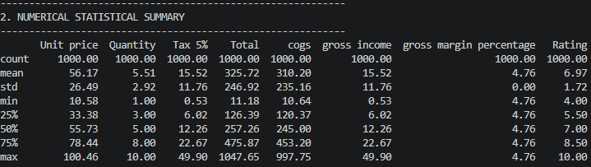

4. Visual Analytics and Key Findings
In this section, we present fourteen visualisations from Python visual analytics. A brief interpretation of the insights obtained from each visualisation is provided. These are a set of visualisations that offer a complete set of visual insights into the store's operations.

4.1 Revenue by Branch
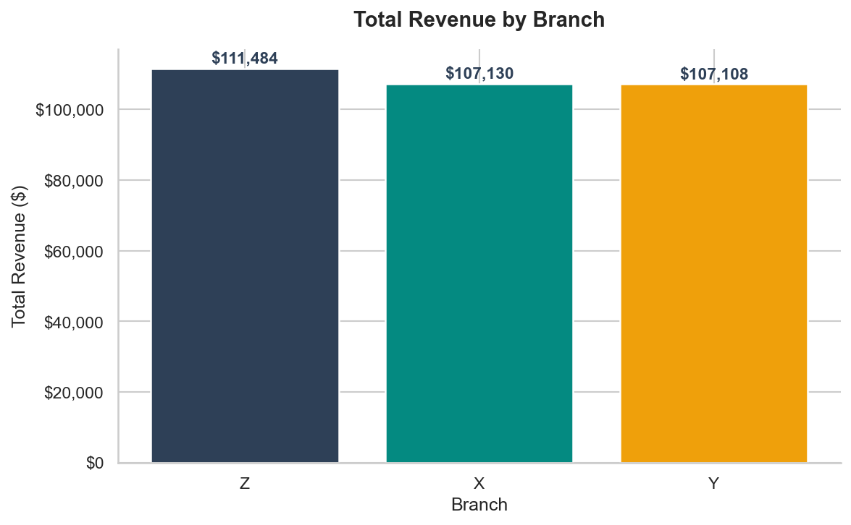
Figure 1: Total Revenue by Branch
Figure 1 shows the total revenue by branch. And the three branches were quite consistent in their performance across the three months, with revenues between $105,000 and $110,000. The slight variations among branches indicate consistent performance across the branches. This establishes a benchmark for measuring future performance or growth, or a decline.

4.2 Revenue by Product Line
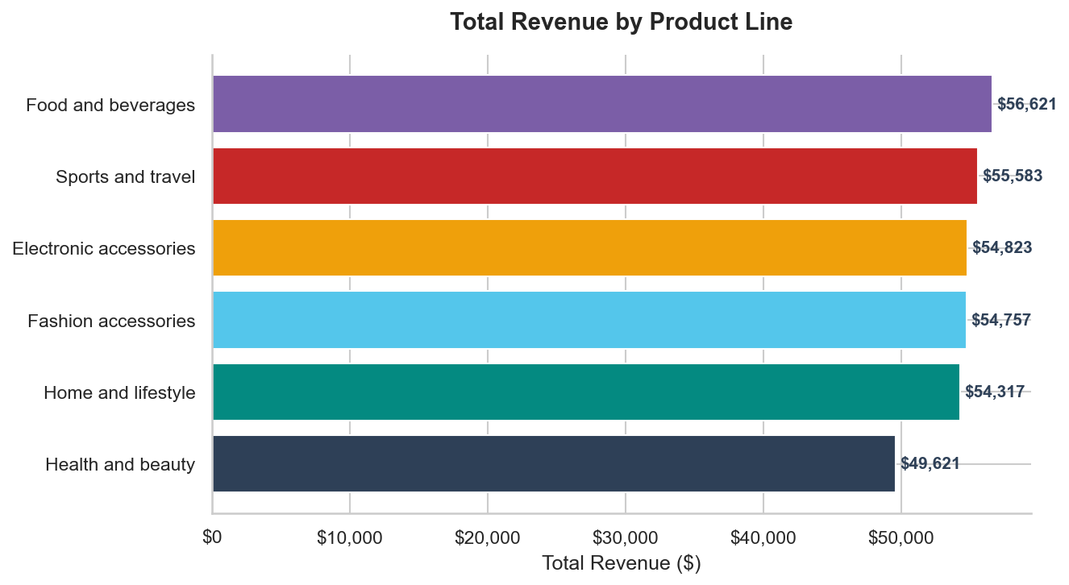
Figure 2: Total Revenue by Product Line
Figure 2 shows the revenue by product line in a horizontal bar chart. The top performing product lines are Food and Beverages, Sports and Travel and Electronic Accessories. The underperformance by Health and Beauty and Home and Lifestyle categories may indicate some opportunities for promotional campaigns and/or negotiating supplier costs to boost product sales in these categories.

4.3 Monthly Revenue Trend
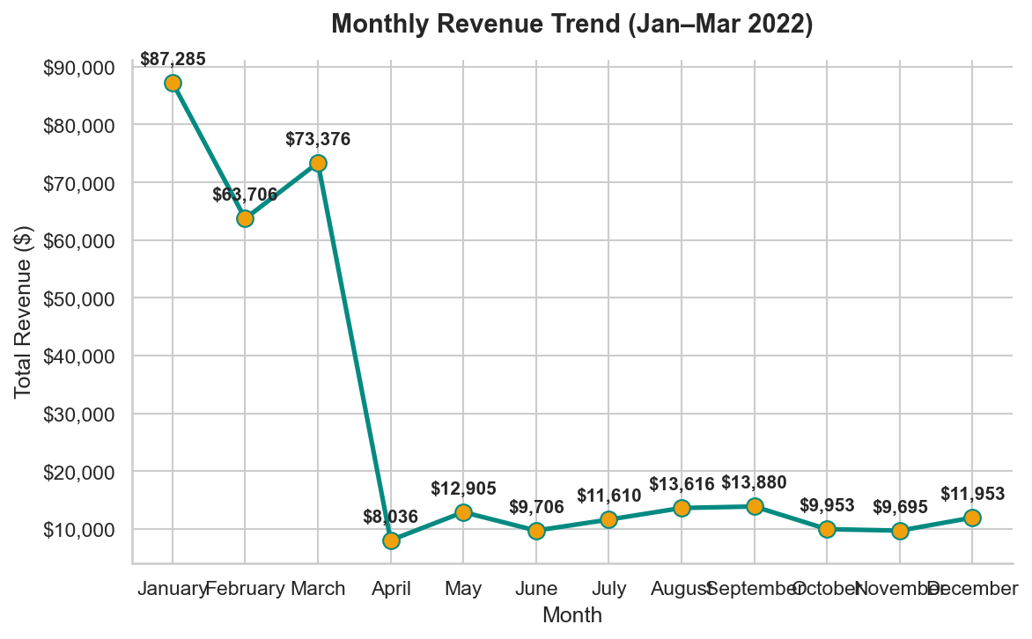
Figure 3: Monthly Revenue Trend (January to March 2022)
This line chart in Figure 3 shows the monthly revenue. Revenue peaked in January, and has declined ever so slightly in the last two months. This pattern may be due to less spending following the January sales. The management should explore the potential of promotional efforts in February and March to reduce this decline and maintain the revenue growth through the quarter.

4.4 Payment Method Distribution
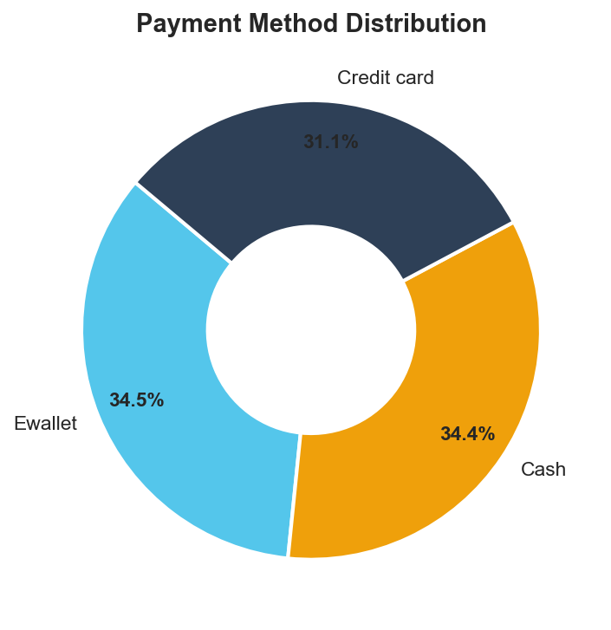
Figure 4: Payment Method Distribution
Figure 4 shows a donut chart of the split of payment methods. The trinity of an equal proportion of Cash, Credit Card and Ewallet suggests a multi-modal payment system. The emphasis on digital payment systems - especially Ewallet and Credit Cards - will minimise the costs associated with handling cash and speed up the transaction time, especially during busy times.

4.5 Customer Rating Distribution
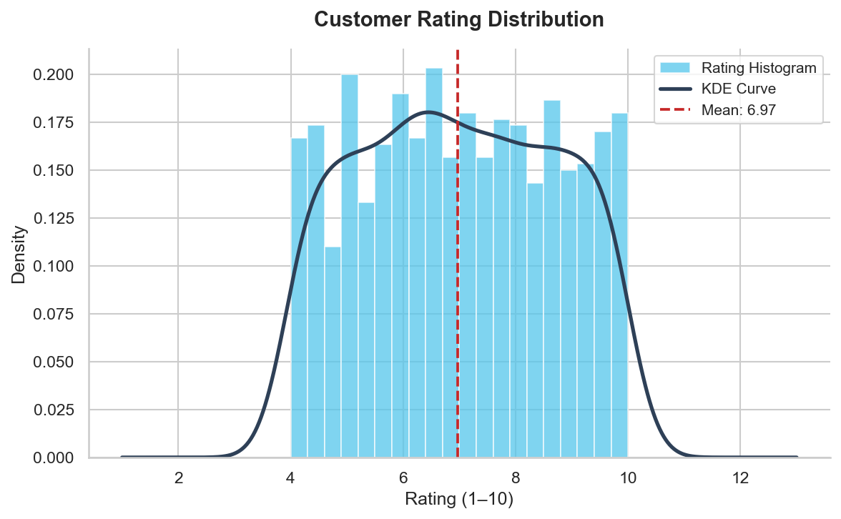
Figure 5: Customer Rating Distribution with KDE Curve
Figure 5 combines a histogram of the customer ratings with a Kernel Density Estimate (KDE) curve, and indicates the average customer rating of 6.97. The ratings appear to be fairly uniformly distributed with no obvious concentration at the ends of the scale. This distribution implies that the service rating is not consistently high or low, and that a focus on improving service quality is needed to drive ratings up.

4.6 Revenue Heatmap: Branch by Product Line
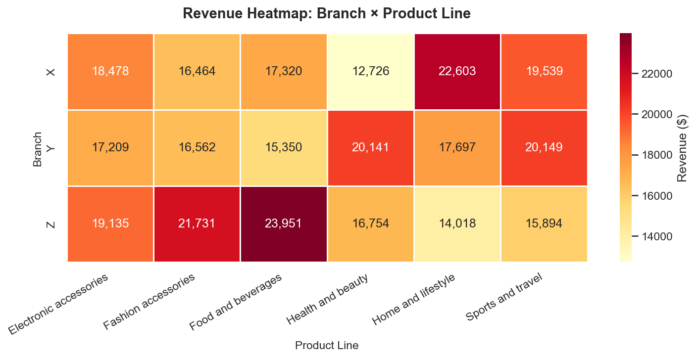
Figure 6: Revenue Heatmap – Branch by Product Line
Figure 6 presents a heatmap of revenue values segmented by branch and product line. Darker cells identify higher-revenue combinations, revealing which product lines drive revenue at specific branches. Food and Beverages appear prominently across all branches, while the distribution of other product lines shows some branch-specific variation, suggesting localised consumer preferences that could inform tailored stocking and marketing strategies at each location.

4.7 Revenue by Gender and Customer Type
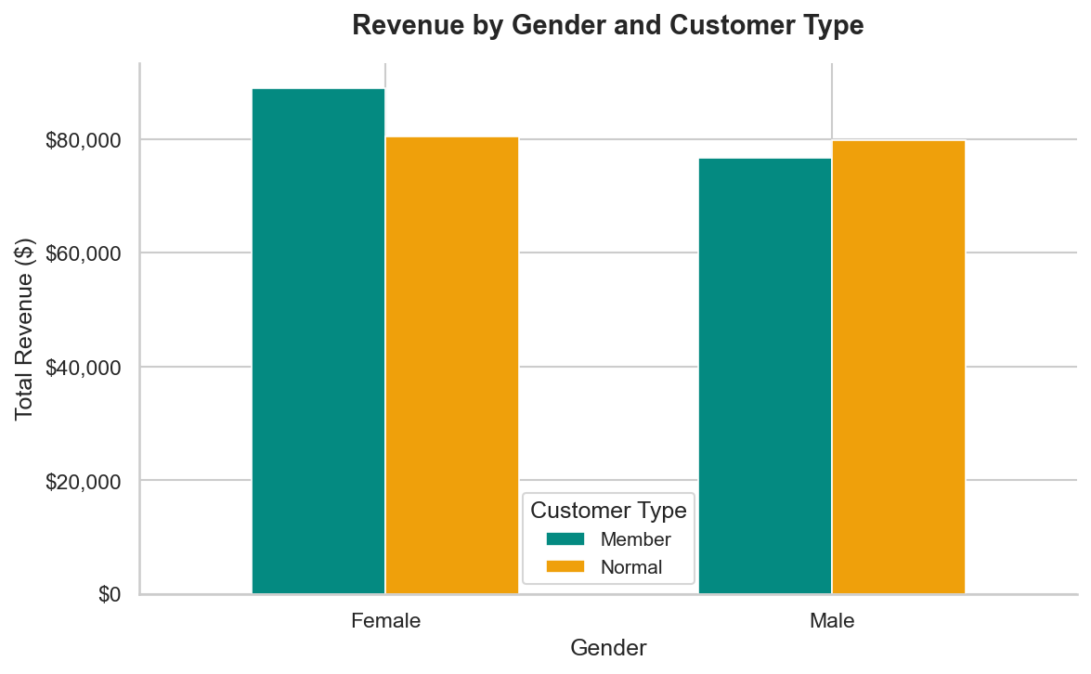
Figure 7: Revenue by Gender and Customer Type
Figure 7 is a grouped bar chart which splits total revenue by gender and customer type (Member or Normal). This graph illustrates an equal contribution of revenue from both male and female, and Member and Normal customers. Members' contribution is on par with Normal customers, implying that the membership program might need to be incentivised to better reward member spending behaviours and to differentiate from current Normal customers.

4.8 Gross Income by Product Line and Branch
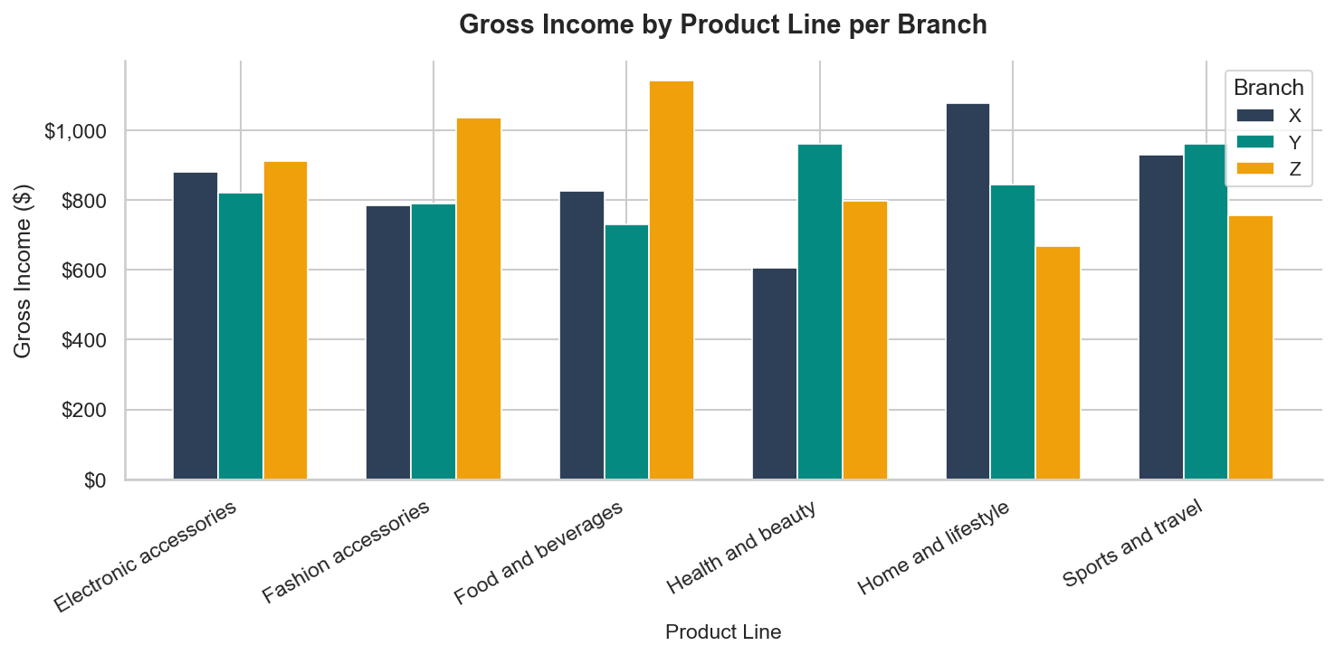
Figure 8: Gross Income by Product Line per Branch
Figure 8 shows gross income by product line, broken down by branch. The graph confirms Food and Beverages; Sports and Travel and Electronic Accessories are the major drivers of gross income across branches. Knowing the product-branch combination with high income allows us to prioritise the investment in those product and branch segments and promote them accordingly.

4.9 Unit Price vs. Total Revenue
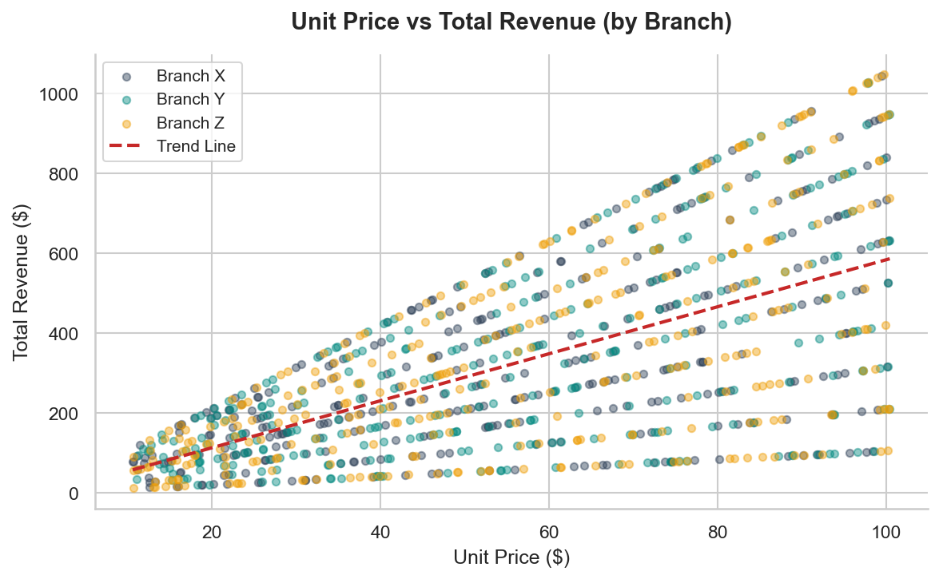
Figure 9: Unit Price vs Total Revenue (by Branch)
Figure 9 is a scatter plot of unit price (per product) vs total revenue with branch data points coloured and a trend line over the data. The upward trend shows that, as expected, unit price increases lead to increased total transaction revenues. The scatter of the points around the trend line suggests that the volume purchased is an important moderating variable, and accounts for much of the variation in total revenue.

4.10 Hourly Sales Volume
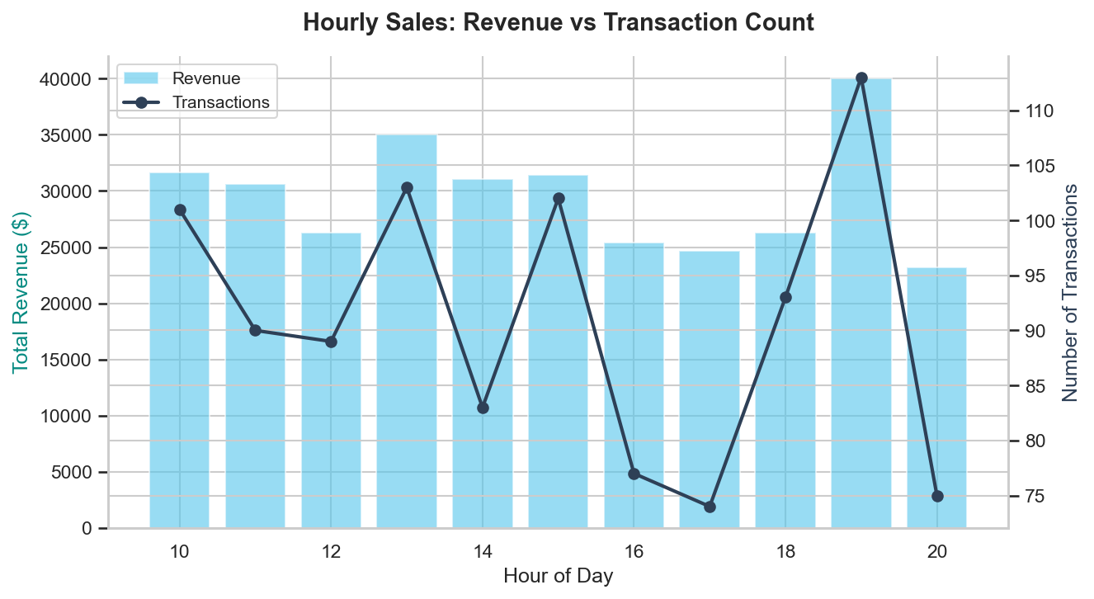
Figure 10: Hourly Sales – Revenue vs Transaction Count
Figure 10 shows hourly sales bars and the hourly line of transaction count to display the hourly sales trend. The busiest hours are in the late afternoon and early evenings, with 19:00 having the highest number of transactions. There is a smaller peak at lunch time. This is important for planning for extra staff and ensuring that sufficient stock is on hand during these busy periods.

4.11 Correlation Heatmap
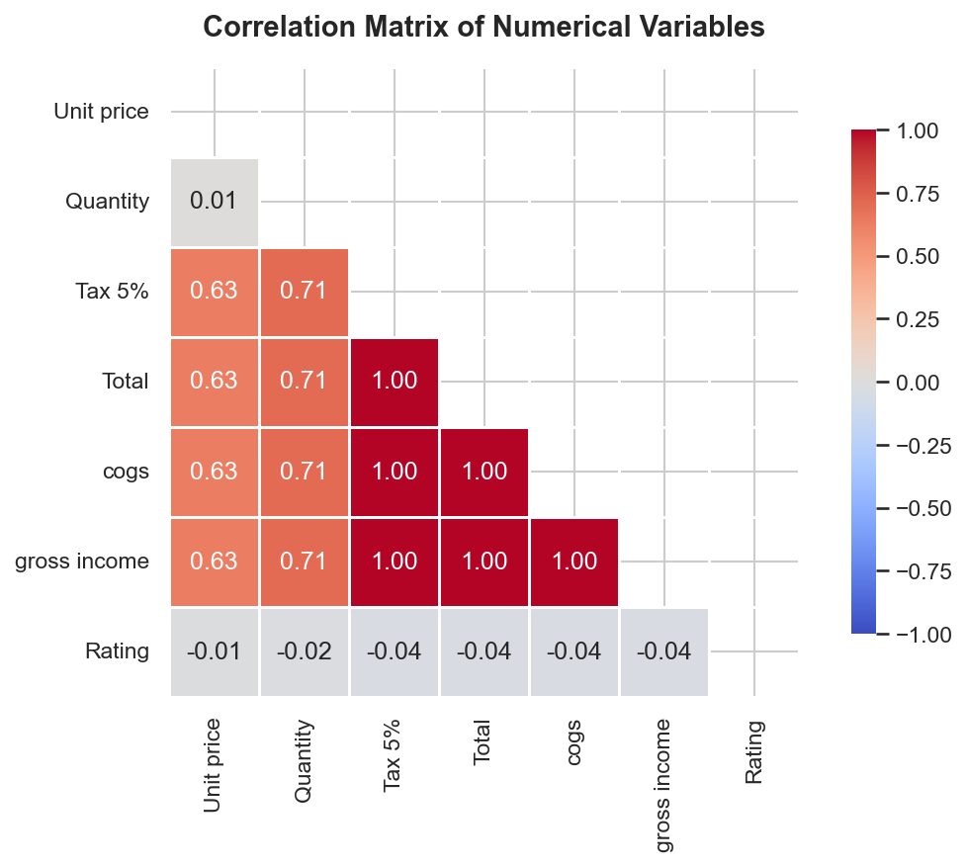
Figure 11: Correlation Matrix of Numerical Variables
Figure 11 shows the lower-triangular matrix of correlations of important numeric variables. Total, COGS, Tax 5% and Gross Income exhibit strong positive correlations - naturally, these variables are interrelated. Modest positive correlations are seen between Quantity and the financial variables, supporting the hypothesis that this driver is a revenue generator. Interestingly, Rating shows weak correlation with all the financial metrics; this confirms that customer rating is not dependent on the amount of transaction, but rather on other service and experience factors.

5. Business Intelligence System Architecture
Business Intelligence (BI) systems provide the technological foundation for an enterprise to convert the raw data from transactional systems into meaningful information. This retail supermarket enterprise architecture is a four-layered approach comprising of Data Sources, ETL (Extract, Transform and Load) Layer, Data Warehouse and the BI (Business Intelligence) and Analytics Layer.
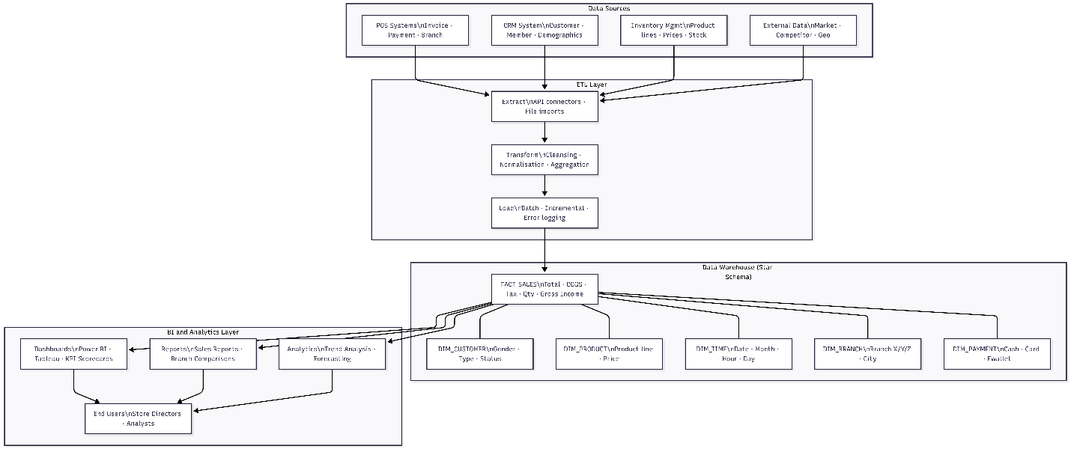
Figure 12: Business Intelligence System Architecture – Retail Store

5.1 Data Sources Layer
This is the first layer which includes all source systems that provide raw data such as point-of-sale systems (sales and orders), customer relationship management systems (customer information), product and stock management systems (products and stock) and external sources (market trends). There needs to be an extraction process in place to deal with the varied data.

5.2 ETL Layer
The ETL (Extract, Transform, Load) layer combines data from various sources. It extracts data from systems, transforms them (cleaning, standardisation and calculation of key metrics), and loads the data into the Data Warehouse. This enables the data to be accurate and fit for analysis.

5.3 Data Warehouse Layer
The Data Warehouse is used for analysis. It is based on a star schema of fact and dimension tables, and allows rapid queries and trend and comparative analysis. Redshift, BigQuery or similar technologies are used.

5.4 BI and Analytics Layer
This layer is used for visualisations in reports and dashboards. Visualisations like KPIs, performance dashboards are provided using tools such as Power BI or Tableau. Proactive analysis such as forecasting, segmentation etc helps in decision-making.

6. Data Warehouse Framework: Star Schema Design
The data warehouse design for the retail supermarket stores data using a star schema design due to its simplicity, performance benefits and support for most BI reporting software. It is comprised of a single Fact Table - FACTSALES - and five Dimension Tables - DIMCUSTOMER, DIMPRODUCT, DIMTIME, DIMBRANCH and DIMPAYMENT.
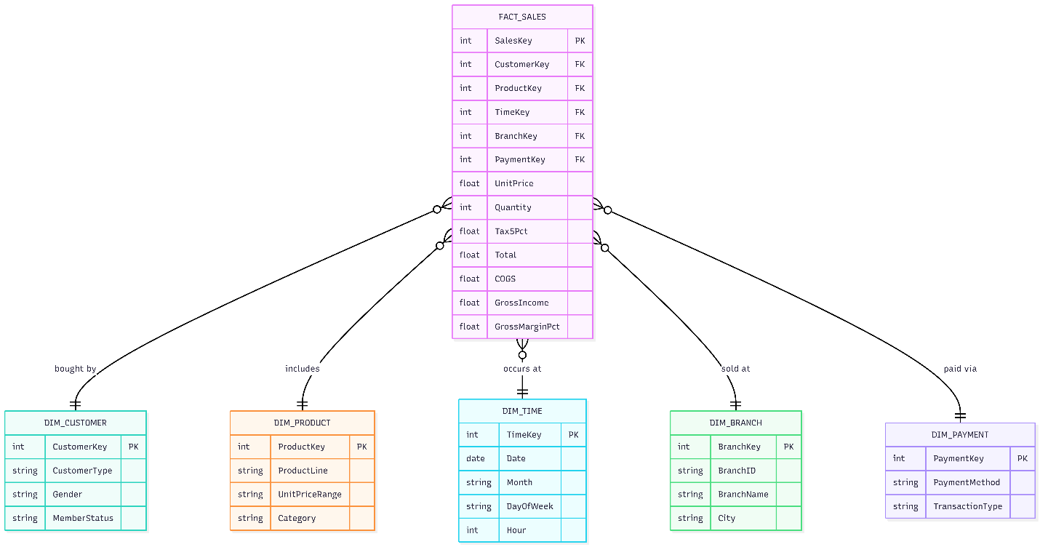
Figure 13: Data Warehouse Star Schema – Retail Store

6.1 Fact Table: FACT_SALES
The FACT_SALES table is the fact table of the schema; it contains a record for each sales transaction. It includes all the quantitative measures: Unit Price, Quantity, Tax 5%, Total revenue, COGS, Gross Income and Gross Margin Percentage. Through foreign key relationships with the dimension tables, we can perform multi-dimensional analysis on the attributes of customers, products, time, branches, and mode of payment.

6.2 Dimension Tables
DIMCUSTOMER stores information on the Customer Type (Member or Normal), Gender and Member Status, enabling analysis by customer demographics. DIMPRODUCT captures Product Line, Unit Price Range, and Product Category, to allow comparisons of product performance. DIMTIME offers a rich time hierarchy of Date, Month, Day of Week, and Hour to support hourly, weekly, monthly and yearly analyses. DIMBRANCH stores Branch ID, Branch Name and City for geographic comparisons. DIM_PAYMENT includes Payment Method and Transaction Type to enable payment channel analytics.

7. Key Performance Indicators
The KPI summary table below lists the key operational and financial indicators from analysing the data set. These are used as a management dashboard for Retail Store Directors to manage the business and assess performance against the targets.

KPI | Value | Remarks
Total Revenue | $322,966.75 | Across all three branches
Total Transactions | 1,000 | Unique invoices processed
Total Gross Income | $15,379.37 | Net after COGS deduction
Avg Gross Margin % | 4.7627% | Consistent across branches
Avg Customer Rating | 6.97 / 10 | Room for service improvement
Avg Transaction Value | $322.97 | Per invoice average spend
Top Branch by Revenue | Branch C | Highest transaction total
Top Product Line | Food & Beverages | Highest revenue generator
Peak Sales Hour | 19:00 (7 PM) | Highest hourly transaction volume

Table 1: Key Performance Indicators Summary

8. Strategic Recommendations
In light of the analyses conducted and presented in this report, the Retail Store Directors are recommended to adopt the following strategy:

8.1 Data Warehouse and BI System Implementation
The proposed star schema and BI system design, when implemented, will give the organisational framework needed for an integrated, real-time performance monitoring of all branches. A data warehouse in the cloud to support an analytical platform, along with a Business Intelligence system (Power BI or Tableau), will allow Store Directors to undertake self-service analytics and provide a platform to support the journey to predictive and prescriptive analytics.

9. Conclusion
This report has outlined a holistic Business Intelligence system architecture and data warehouse design for a three-store retail supermarket company, using visual analytics to analyse 1,000 transactions for the periods from January to March 2022. Using a mix of statistical analysis and 13 visualisations, the report has revealed insights into branch revenue performance, demand for product lines, customer demographics, customer's preferred payment method, temporal trading patterns and customer satisfaction.
Continued investment in Business Intelligence will ensure the retail supermarket can react and adapt to changing consumer trends, allocate resources efficiently and gain competitive advantage in the ever-evolving, data-driven retail landscape.

References
Han, J., Kamber, M., & Pei, J. (2011). Data Mining: Concepts and Techniques (3rd ed.). Morgan Kaufmann Publishers.
Kimball, R., & Ross, M. (2013). The Data Warehouse Toolkit: The Definitive Guide to Dimensional Modeling (3rd ed.). Wiley.
Inmon, W. H. (2005). Building the Data Warehouse (4th ed.). Wiley Publishing.
Loshin, D. (2012). Business Intelligence: The Savvy Manager's Guide (2nd ed.). Morgan Kaufmann.
Few, S. (2009). Now You See It: Simple Visualization Techniques for Quantitative Analysis. Analytics Press.

Appendix: Codebase
